# Table of Contents

Table of Contents 1

Table of Figures 1

Required libraries. 1

Data importation 1

Data Exploration and cleaning 1

Display top Five rows of the dataset. 1

Display last five rows of the dataset. 2

Find shape of the dataset(Number of rows and number of columns) 2

Get overall statistics About the data. 2

Data Analysis 2

K-Means clustering 2

Import Required tools for K-Mean clustering 3

Making predictions 3

Model optimization 3

Visualizing the plot of clusters 4

Create our GUI(Graphical user interface) 6

# Table of Figures

Figure 1:cummulative Bar Chart 2

Figure 2:Year Of Study Pie Chart 5

[1]

# Required libraries.

Import pandas As pd

# Data importation

Data=pd.read_csv(“Mall_Customers.csv”)

Questions

# Data Exploration and cleaning

## Display top Five rows of the dataset.

Data.head()

## Display last five rows of the dataset.

Data.tail()

## Find shape of the dataset(Number of rows and number of columns)

Data.shape()

4.Get information about our dataset Like total Number of Rows Total Number of columns, Datatypes of each type and memory allocation.

Data.info()

5.Check Null Values in The dataset

Data.isnull().sum()

## Get overall statistics About the data.

Data.describe()

# Data Analysis

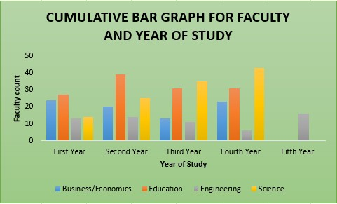

Figure 1:cummulative Bar Chart

## K-Means clustering

To display columns in our dataframe

Data.columns

We are using only two of them and then call to see how it looks

X=data[[‘Annual Income (k$)’,’Spending Score (1-100)’]]

X

## Import Required tools for K-Mean clustering

From sklearn.cluster import KMeans

k-means=KMeans()

fit()-> only trains our algorithm

k-means.fit(x)

k-means=KMeans()

# Making predictions

fit_predict->trains and predict dependent variable which is the cluster

k-means.fit_predict(x)

By default There Are 8 clusters which are predicted

## Model optimization

8.Elbow Method to find optimal number of Clusters.

Optimal number of clusters are at the elbow of the plot

WCSS->Within cluster sum of squares. It is stored in a list

WCSS[]

For i in range(1,11)

k-means=KMean(n_cluster=i)

k-means.fit(x)

WCSS.append(k_means.inertia_)

Check the values

WCSS()

Visualizing the values

We use the mathplot library

Import matplotlib.pyplot as plt

plt.plot(range(1,11),WCSS)

plt.title(“Elbow Method”)

plt.xlabel(“Number OF Clusters”)

plt.ylabel(“WCSS”)

plt.show()

9.Training the model

Optimal number of clusters are 5

X=data[[‘Annual Income (k$)’,’Spending Score (1-100)’]]

k-means=KMeans(n_clusters=5,random_state=42)

y_means=k_means.fit_predict(x)

y_means

## Visualizing the plot of clusters

Plt.scatter(x.iloc[y_means==0,0],x.iloc[y_means==0,1],s=100,c=’red’,label=’Cluster 1’)

Plt.scatter(x.iloc[y_means==1,0],x.iloc[y_means==1,1],s=100,c=’blue’,label=’Cluster 2’)

Plt.scatter(x.iloc[y_means==2,0],x.iloc[y_means==2,1],s=100,c=’yellow’,label=’Cluster 3’)

Plt.scatter(x.iloc[y_means==3,0],x.iloc[y_means==3,1],s=100,c=’black’,label=’Cluster 4’)

Plt.scatter(x.iloc[y_means==4,0],x.iloc[y_means==4,1],s=100,c=’green’,label=’Cluster 5’)

Plt.scatter(k_means.cluster_centers_[:,0], k_means.cluster_centers_[:,1],s=100,c=’magenta)

Plt.title(“Customer Segmentation”)

Plt.xlabel(“Annual Income”)

Plt.ylabel(“Spending Score”)

Plt.legend()

Plt.show()

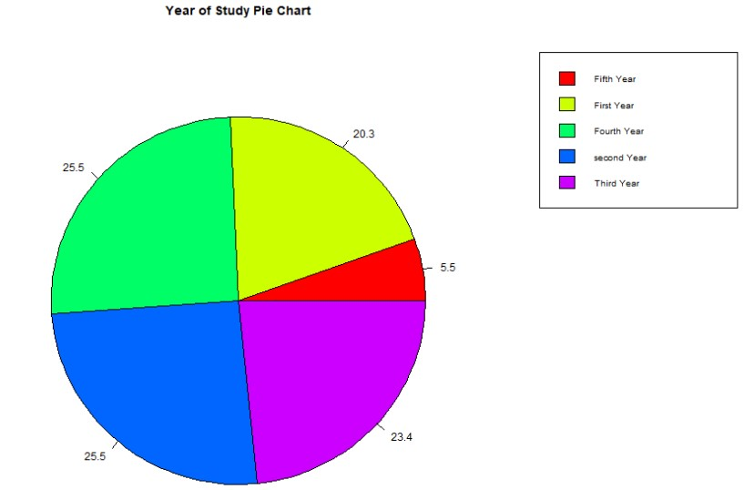

Figure 2:Year Of Study Pie Chart

Predicting

K_means.predict([[15,39]])

Saving The Model

Import joblib

joblib.dump(k_mean,” Customer_Segmentation”)

model=joblib.load(” Customer_Segmentation”)

def show_entryfields():

p1=int(e1.get())

p2=int(e2.get())

model=joblib.load(‘ Customer_Segmentation’)

result=predict([[p1,p2]])

print(“This Customer Belongs To Cluster Number: “, result[0])

if result[0]==0:

label(master,text=”Customer with medium annual income and medium”

## Create our GUI(Graphical user interface)

From tkinter import*

Import joblib

1. Wish Its Helpful